**Project Development Phase**

**Delivery of Sprint-2**

|  |  |
| --- | --- |
| **Date:** | **09.11.2022** |
| **Team ID :** | **PNT2022TMID30903** |
|  |  |
| **Team Members:** | **Abitha S**  **Bavisni R**  **Kaviyadharshini G**  **Shanmugavel B** |
|  |  |
| **Project Name :** | **Analytics for Hospital Health-Care Data** |
|  |  |

Download Dataset:- <https://drive.google.com/file/d/1t2PVp4xOzr94GFXRWz5WBOBv_nE4OGKu/view>

Challenge:- Upload the dataset to Cognos Analytics, prepare the data, explore and Create Interactive

Dashboard.

Task 1:Sales By Customer.

Task 2:Sales By Location.

Task 3:Sales By Sales Representative.

Task 4: Received Inventory From Supplier

Task 5: Inventory Stock for Warehouse Locations

Task 6: Sales Trend

Task 7:Monthly Sales

Task 8: Actual and Received Inventory by Month

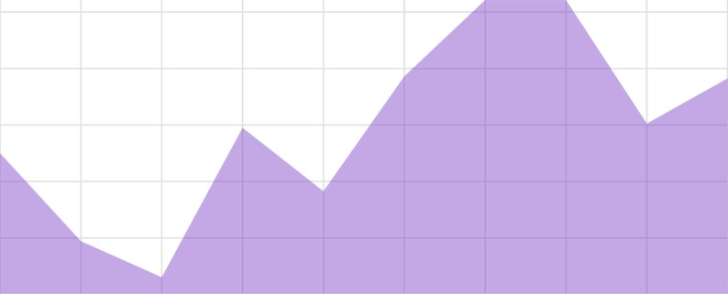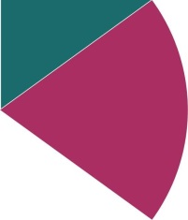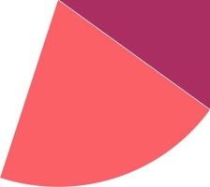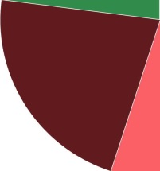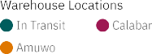

* 1. **Number Of Patients By Ward Types**
  2. **Dashboard To Show Number Of Patients**
  3. **Age Wise Patients With Department And Severity Filters**
  4. **Dashboard With Hierarchy Bubble And Radial Visuals**
  5. **Dashboard Showing Pie, Stacked Bar, Waterfall And Pie Charts**

